**Assignment 1: Portfolio Fusion: Report Document**

**Netlify link**: <https://isys3004-asse1-19174279.netlify.app/>

Contents

AI conversations 2

Before & After implementation 2

1st implementation 2

AI CODE 4

2nd Implementation 9

AI Code 10

A brief reflection 11

Lessons learned about working with AI for development. 11

Any non-compliant issues 12

# AI conversations

All full script has been uploaded to the GitHub repository this is a sectional of snippets to show for the report example.

# Before & After implementation

## 1st implementation

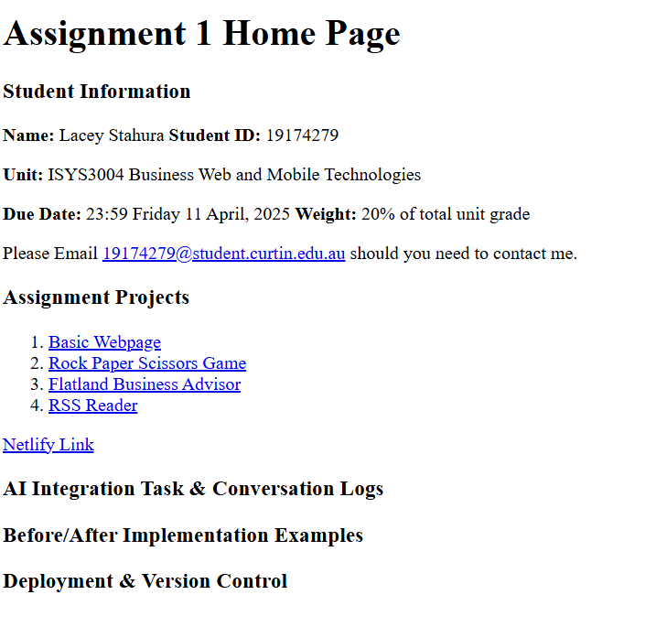

The above snippet was the first attempt I made with the basic template from classes, and it has all basic and essential needs for the home page but in the interest of accessibility I wanted to see what AI could come up with.

**The blow is the coding for this.**

<!DOCTYPE html>

<html lang="en">

<head>                                                        <!-- Meta information - not visible on the page -->

    <meta charset="UTF-8">

    <link rel="stylesheet" href="css/styles.css">                 <!-- link to external css style sheet -->

    <meta name="viewport" content="width=device-width, initial-scale=1.0">                  <!-- Makes the page responsive on different devices -->

    <title>Assignment 1 Home Page 19174279</title>                      <!-- Sets the title shown in browser tabs and bookmarks -->

    <nav>

    <a href="#returnhome">Return Home</a>

    </nav>

</head>

<body>                                    <!-- All visible content goes within the body -->

    <h1>Assignment 1 Home Page</h1>      <!-- Heading elements (h1-h6) create hierarchical structure -->

    <h3>Student Information</h3>

    <!-- Paragraph element for text content, basic information required for identification and general header -->

    <p><strong>Name: </strong>Lacey Stahura <strong>Student ID: </strong>19174279 </p>

    <p><strong>Unit: </strong>ISYS3004 Business Web and Mobile Technologies</p>

    <p><strong>Due Date:</strong> 23:59 Friday 11 April, 2025 <strong>Weight:</strong> 20% of total unit grade</p>

    <p>Please Email <a href="mailto:19174279@student.curtin.edu.au">19174279@student.curtin.edu.au</a> should you need to contact me.</p>  <!-- Email link -->

    <p>*MAKE THIS LINE AN ADDITIONAL SPACE* </p>

    <h2>Assignment Projects</h2>                             <!-- Listed Projects -->

    <ol>

        <li>Week 2: Basic Webpage (HTML & CSS)</li>

        <li>Week 3: Rock Paper Scissors Game (Simple JS interactions)</li>

        <li>Week 4: Flatland Business Advisor (DOM Manipulation)</li>

        <li>Week 5: RSS Reader (API Call using Fetch API)</li>

    </ol>

    <h3>AI Integration Task & Conversation Logs</h3>

    <h3>Before/After Implementation Examples</h3>

    <h3>Deployment & Version Control</h3>

    <h4>Optional Bonus Task: Code Review & Future Improvements</h4>

</body>

</html>

### AI CODE

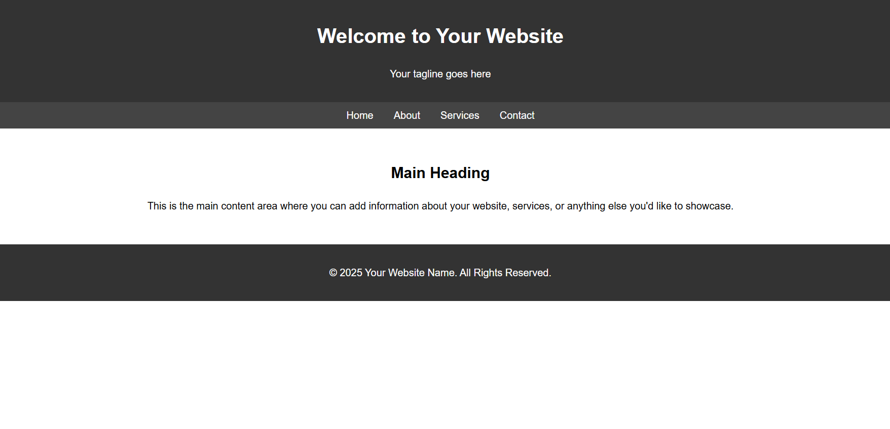

**The code AI provided was (**[**https://www.perplexity.ai/search/can-you-make-me-a-webpage-html-eHA81VpsSyGBjcyx719eeg**](https://www.perplexity.ai/search/can-you-make-me-a-webpage-html-eHA81VpsSyGBjcyx719eeg) )  
<!DOCTYPE html>

<html lang="en">

<head>

<meta charset="UTF-8">

<meta name="viewport" content="width=device-width, initial-scale=1.0">

<meta name="description" content="Your website description here">

<meta name="author" content="Your Name">

<title>Your Website Title</title>

<link rel="stylesheet" href="styles.css"> <!-- Link to external CSS -->

<style>

/* Basic CSS for styling */

body {

font-family: Arial, sans-serif;

margin: 0;

padding: 0;

line-height: 1.6;

}

header {

background: #333;

color: #fff;

padding: 1rem 0;

text-align: center;

}

nav {

background: #444;

padding: 0.5rem;

}

nav ul {

list-style: none;

margin: 0;

padding: 0;

display: flex;

justify-content: center;

}

nav ul li {

margin: 0 1rem;

}

nav ul li a {

color: #fff;

text-decoration: none;

}

main {

padding: 2rem;

text-align: center;

}

footer {

background: #333;

color: #fff;

text-align: center;

padding: 1rem 0;

}

</style>

</head>

<body>

<!-- Header Section -->

<header>

<h1>Welcome to Your Website</h1>

<p>Your tagline goes here</p>

</header>

<!-- Navigation Bar -->

<nav>

<ul>

<li><a href="#home">Home</a></li>

<li><a href="#about">About</a></li>

<li><a href="#services">Services</a></li>

<li><a href="#contact">Contact</a></li>

</ul>

</nav>

<!-- Main Content Section -->

<main>

<h2>Main Heading</h2>

<p>This is the main content area where you can add information about your website, services, or anything else you'd like to showcase.</p>

</main>

<!-- Footer Section -->

<footer>

<p>&copy; 2025 Your Website Name. All Rights Reserved.</p>

</footer>

</body>

</html>

The AI created a far more structured approach in terms of display, whereas I had focused on contact. The outcome of merging the two with a few changes to match my personal preferences, but still shows information in a clear format and links work effectively.

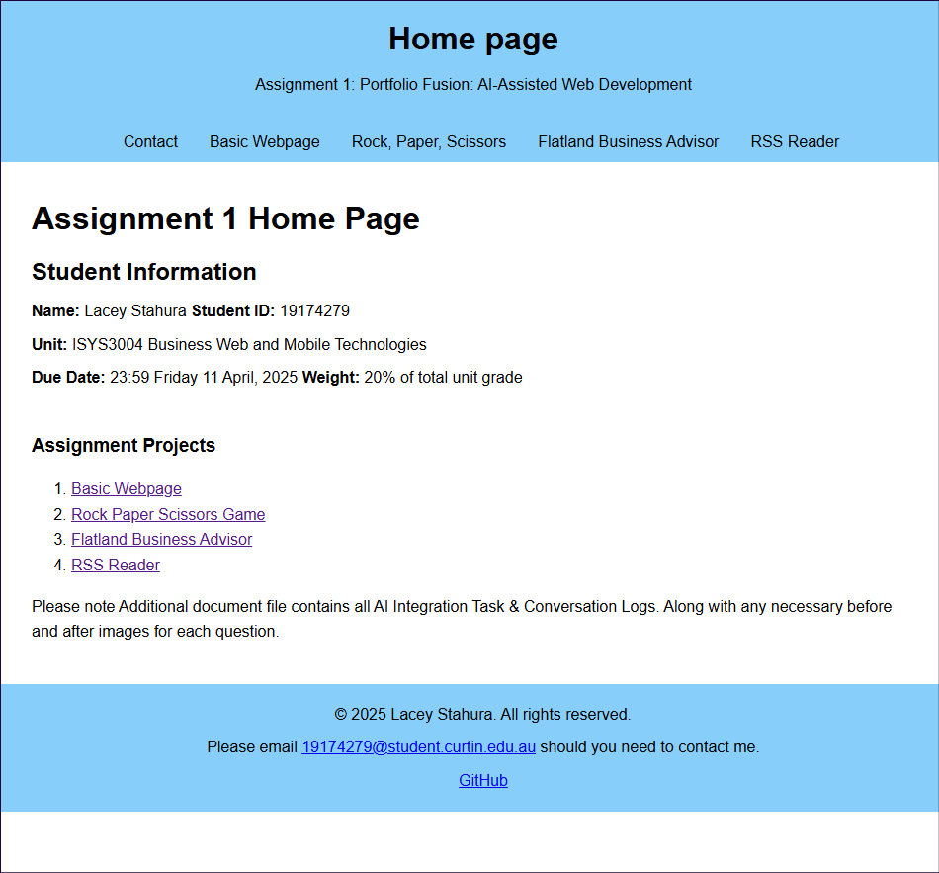

This then became the base style for all pages and can really change a very basic page – as can be seen in the stages in the below images of the fetching page.

This was the code functionally working without style application.

The base template was modified and then applied to all project pages and completely changes the pages focus.

## 2nd Implementation

This implementation is not nearly as dramatic but is still evident. Despite only being a formatting issue to create and putting my square in the main section, a simple error that can make all the difference, which can be seen in the before and after photos. There is no visual separation between the content of which is the Flatland Square, and the header and footer.

Using AI to assist with this simple style implementation was quick, easy and very effective. It did suggest using a shadow, but I felt that drew more attention to the fact that it was a standalone in the middle of a page versus a visually flowing webpage.

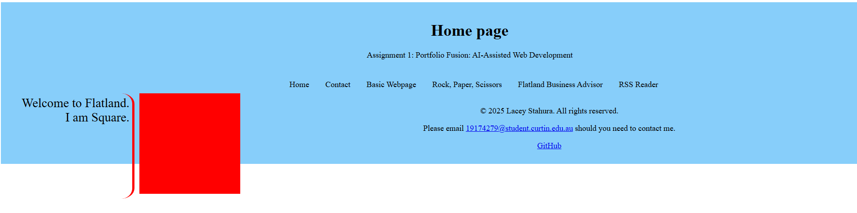

Using AI to assist with this simple style implementation was quick, easy and very effective. It did suggest using a shadow, but I felt that drew more attention to the fact that it was a standalone in the middle of a page versus a visually flowing webpage.

### AI Code

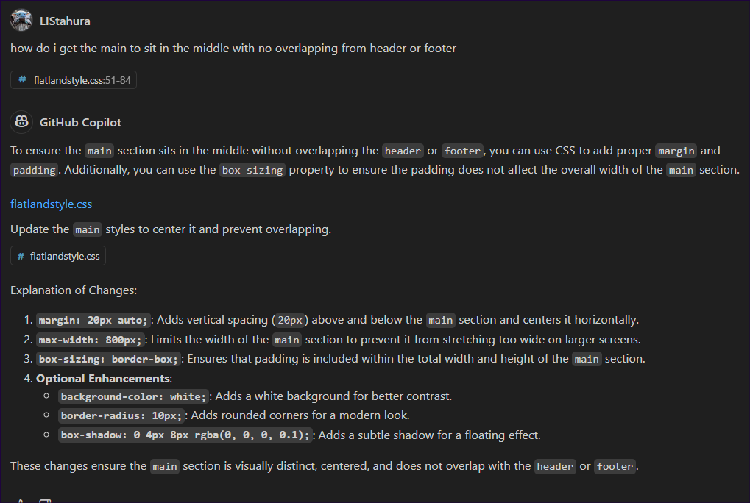

# A brief reflection

It’s hard to sometimes differentiate between using AI as a tool and getting AI to do things for you, and depending on which type of AI used may affect this. Throughout this assignment, I used a combination of perplexity AI on a webpage and the GitHub Copilot AI embedded within the Visual Studio Code application. Both are very effective and assisted me in understanding and changing the work I was doing, and helped improve the learning and webpage-building experience.

Some elements were much harder to comprehend and manipulate than others, and although having AI create a template for you if you don’t understand what’s going on, then it’s not a very effective template, nor will you be able to manipulate it appropriately to get the desired design and results. If you change your perspective on how you see AI, instead of it being something to do for you and using it as a tool to help understand, it changes the entire use of an AI platform.

By using AI efficiently, you’re not only basically have a personal tutor who can explain things to you at a preferred level as things occur and provide working examples to help you. I can see in some cases, this may lead to people not actively learning and remembering how to do this as it will not be necessary in future with technological advancements.

## Lessons learned about working with AI for development.

Depending on the AI the conversations can be downloaded easily (perplexity AI) while others clearly have no interest in being exported (copilot in VS code).

While using AI is convenient the format of VS code and it Copilot side bar chat trying to export the conversation and have a method of tracking what has been done it is not easy to export in a view for submission. Please note only export methos is a JSON file which has been included in GitHub repository.

# Any non-compliant issues

The only non-compliance error is in the rock paper scissors js and script. The error shown mentions an uncaught type error. I have also tried to use AI to fix this and it cannot seem to fix it all, then it seems to contradict itself, so I have left it, as is, since the page still works with the error.

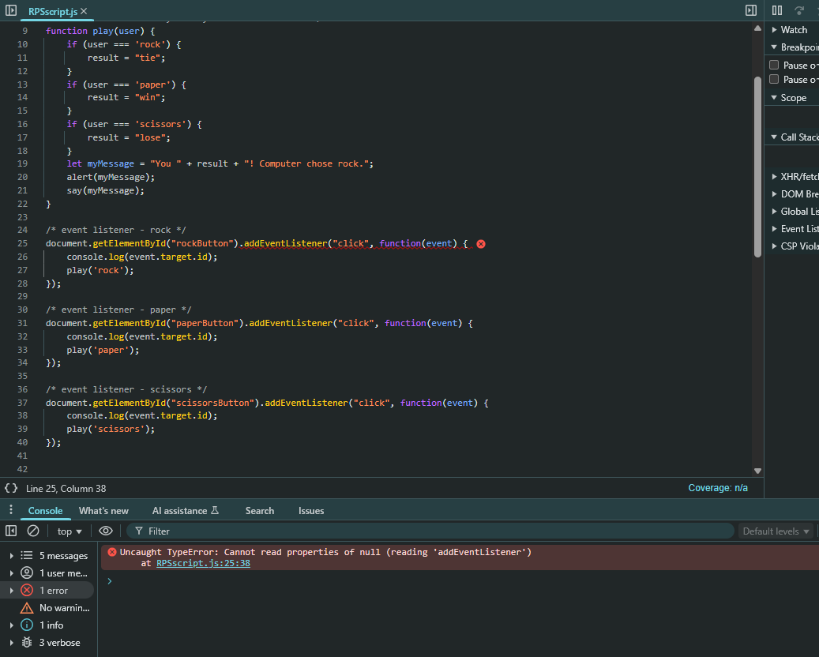

Could also only export copilot chat as JSON file and have to the best of my ability screenshotted and included as word doc.